1. Sàng nguyên tố

Phân tích thừa số nguyên tố thì xác định **số đó có bao nhiêu ước.**

Tính được tích

Ước chung lớn nhât 2 số

Ly thuyet dong du

Phep cong

Phep nhan

Mu

Fibo

Fibo quy hoach dong

Công thức lũy thừa nhị phân

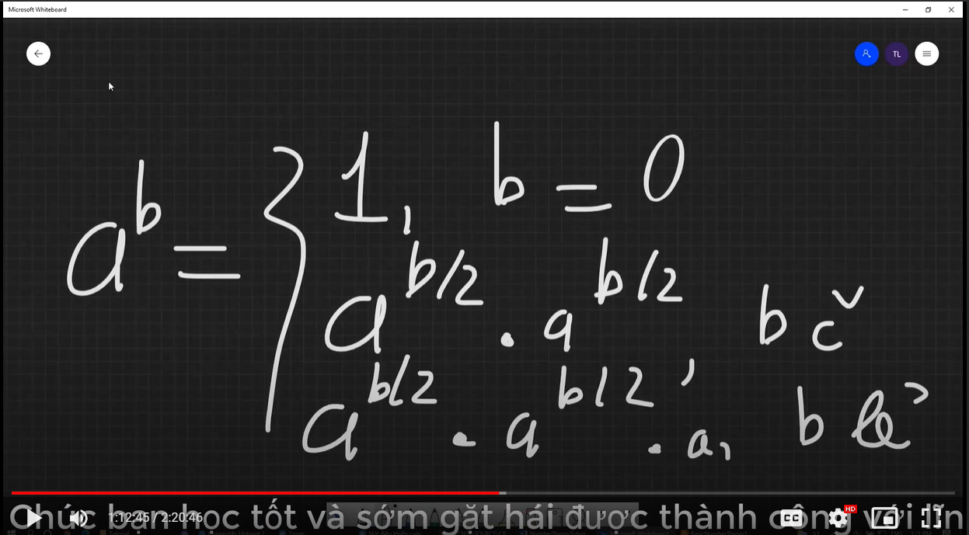

Dem uoc cua n la so chan

